
Amazon Interview Worksheet
EARN TRUST
Definition and Indicators
Earn Trust: Leaders listen attentively, speak candidly, and treat others respectfully. They are vocally self-critical, even when doing so is awkward or embarrassing. Leaders do not believe their or their team’s body odor smells of perfume. They benchmark themselves and their teams against the best.
What this looks like in Practice
As a people manager do you… | As an individual contributor do you…
- Earn the trust and respect of the team and build positive working relationships by consistently making good decisions, keeping commitments, treating others and their ideas with respect, and adhering to high ethical standards?
- Provide an environment where team members have room to take smart risks and learn from mistakes while not losing sight of their accountability for results?  - Listen, communicate and delegate to help employees get the right things done? | - Do what you say you will do or appropriately reset expectations?  - Honor commitments made to other teams even if your own goals are in jeopardy?

Earn Trust - Suggested Behavioral Interview Questions
For each question you choose, use a separate STAR Worksheet
Questions for (Manager) in parentheses

- Describe a time when you significantly contributed to improving morale and productivity on your team. What were the underlying problems and their causes? How did you prevent them from negatively impacting the team in the future?
- What three things you are you working on to improve your overall effectiveness?
- Give an example of a tough or critical piece of feedback you received. What was it and what did you do about it?
- Give me an example of an idea you had that was strongly opposed. Why was there so much resistance? How did you handle the negative feedback?
- Give me an example of a significant professional failure. What led you to making the wrong decision? What did you learn from this situation?
- Give an example of a time where you were not able to meet a commitment to a team member. What was the commitment and what prevented you from meeting it? What was the outcome and what did you learn from it?
- Building trust can be difficult to achieve at times. Tell me about how you have effectively built trusting working relationships with others on your team.
- Describe a time when you needed the cooperation of a peer who was resistant. What did you do? What was the outcome?
- Tell me about a piece of direct feedback you recently gave to a colleague. How did s/he respond? How do you like to receive feedback from others?
- Tell me about a time you had to communicate a big change in direction for which you anticipated people would have a lot of concerns. How did you handle questions and/or resistance? Were you able to get people comfortable with the change?
- Tell me about a time your team’s goals were out of alignment with another team on which you relied to attain a key resource. How did you work with the other team? Were you able to achieve your goals? (Manager)
- Tell me about a time you uncovered a significant problem in your team. What was it and how did you communicate it to your manager and to your peers or other stakeholders? (Manager)
STAR WORKSHEET
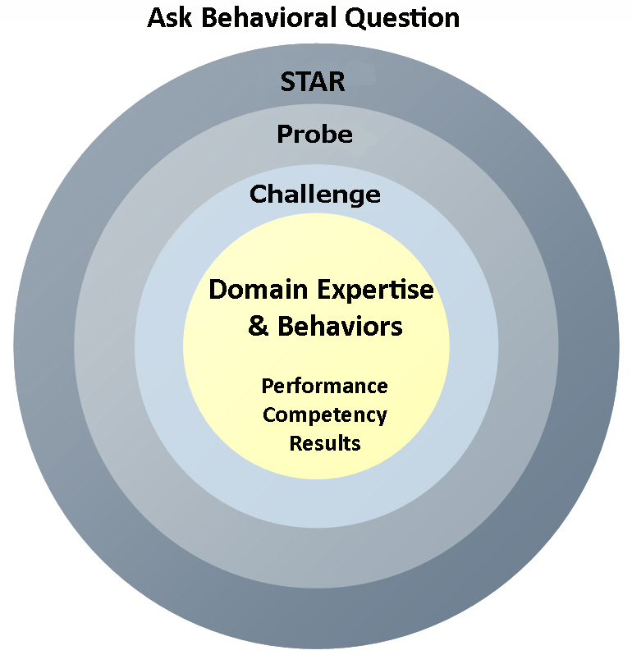
Your Behavioral Question:___________________________________________________________________Leadership Principle:_________________

- Choose behavioral question that provoke specific examples or stories for your assigned Leadership Principle(s).
- Process the example using STAR. Stories have beginnings (Situation/Task), middles (Actions) and ends (Results).
- Once you have established the story, PROBE to dive deeper on your assigned competency (Leadership Principle), get clarity or pursue a concern.
- If appropriate, CHALLENGE the candidate’s statements, decisions or thought process.
S  T | SITUATION/TASK - Describe the situation/task you faced and the context of the story  Answers the questions: where did this occur, when did it happen, why is it important?  Probing Questions:  - Why is this important? What was the goal?  - What was the initial scope of the project? What were the challenges?  - What were the risks and potential consequences if nothing happened?  Challenge Questions:  - Why did you choose this story to illustrate a xyz accomplishment?  - What other stories can you think of that demonstrate.. xyz?  - Could you come up with an example that is more recent? | Notes
A | ACTION - What actions did you take?  Answers the questions: what did you personally own, how did you do it, who else was involved?  Probing Questions:  - Deep probe functional expertise and/or assigned core competency.  - Were you the key driver or project owner?  - What was your biggest contribution? What unique value did you bring?  - What were the most significant obstacles you faced? How did you overcome them?  Challenge Questions:  - What did you do specifically versus the team?  - How did you set priorities…deal with xyz problem… or get manager buy-in?  - What decisions did you challenge? Why? How did you influence the right outcome?
R | RESULTS - How did you measure success for this project? What results did you achieve?  $ Cost savings, revenue generation  # Quantify to understand volume, size, scale  % Percentage change, year over year improvements  Time to market, implementation time, time savings  Impact on the customer, the team  δ Quality improvements  Probing Questions:  - Why did you choose to focus on these results? What other results were important?  - You mentioned revenue, what percentage change is that year over year?  - What trade-offs did you have to make to achieve this? (quality, cost, time)  - I’m concerned about… (the time it took, the volume, the customer impact), tell me more…  Challenge Questions:  - What were the lessons learned? What would you have done differently?  - How would you implement this at Amazon?  - How did these results compare to your actual goals? (refer back to goal stated in Situation)

